# **PIZZA SALES SQL QUERIES**

# **A.KPI’s**

**1. Total Revenue**  
SELECT SUM(total_price) AS Total_Revenue FROM pizza_sales

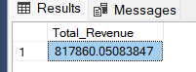

**2. AVERAGE ORDER VALUE**

SELECT SUM(total_price)/ COUNT(Distinct order_id) As Avg_Order_Value FROM pizza_sales

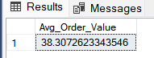

**3. TOTAL PIZZA SOLD**

SELECT SUM(quantity) AS Total_Pizza_Sold FROM pizza_sales

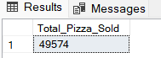

**4. TOTAL ORDERS**  
SELECT COUNT(DISTINCT order_id) AS Total_Orders FROM pizza_sales

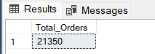

**5.AVERAGE PIZZA PER ORDER**

SELECT CAST (CAST(SUM(quantity) AS DECIMAL(10,2)) / CAST( COUNT(DISTINCT order_id) AS DECIMAL (10,2)) AS DECIMAL(10,2)) As Avg_Pizza_Per_order FROM pizza_sales

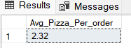

# **PROBLEM STATEMENT**

**1. DAILY TRENDS FOR TOTAL ORDER**

SELECT DATENAME(DW,order_date) AS order_day, COUNT(DISTINCT order_id) AS Total_orders FROM pizza_sales Group by DATENAME(DW,order_date)

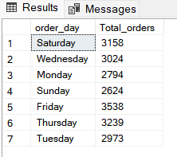

**2.MONTHLY TREND FOR TOTAL ORDERS**

SELECT DATENAME(MONTH,order_date) AS Month_Name, COUNT(DISTINCT order_id) AS Total_Orders FROM pizza_sales GROUP BY DATENAME(MONTH,order_date) ORDER BY Total_Orders DESC

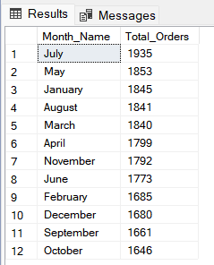

**D. % of Sales by Pizza Category**

SELECT pizza_category, CAST(SUM(total_price) AS DECIMAL(10,2)) as total_revenue, CAST(SUM(total_price) * 100 / (SELECT SUM(total_price) from pizza_sales) AS DECIMAL(10,2)) AS PCT FROM pizza_sales GROUP BY pizza_category

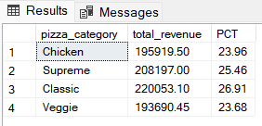

**E. % of Sales by Pizza Size**

SELECT pizza_size,CAST (SUM(total_price) AS DECIMAL(10,2)) AS Total_revenue , CAST(SUM(total_price)*100 / (SELECT SUM(total_price) FROM Pizza_sales)AS DECIMAL (10,2)) AS PCT FROM pizza_sales GROUP BY pizza_size ORDER BY PCT DESC

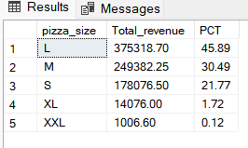

**G. Top 5 Pizzas by Revenue**

SELECT TOP 5 pizza_name, SUM(total_price) AS Total_Revenue FROM Pizza_sales GROUP BY pizza_name ORDER BY Total_Revenue DESC

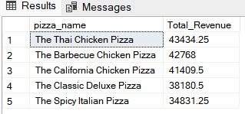

**H. Bottom 5 Pizzas by Revenue**

SELECT TOP 5 pizza_name, SUM(total_price) AS Total_Revenue FROM Pizza_sales GROUP BY pizza_name ORDER BY Total_Revenue ASC

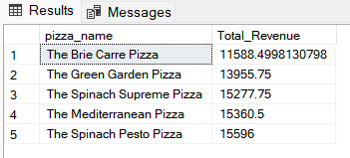

**J. Bottom 5 Pizzas by Quantity**

SELECT TOP 5 pizza_name, SUM(Quantity) AS Total_Quantity FROM Pizza_sales GROUP BY pizza_name ORDER BY Total_Quantity DESC

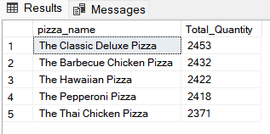

**I. Top 5 Pizzas by Quantity**

SELECT TOP 5 pizza_name, SUM(Quantity) AS Total_Quantity FROM Pizza_sales GROUP BY pizza_name ORDER BY Total_Quantity ASC

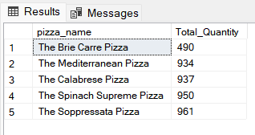

**K. Top 5 Pizzas by Total Orders**

SELECT TOP 5 pizza_name, COUNT(Order_id) AS Total_Orders FROM Pizza_sales GROUP BY pizza_name ORDER BY Total_Orders DESC

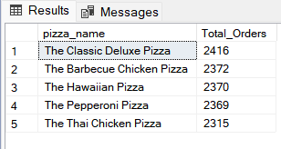

**L. Borrom 5 Pizzas by Total Orders**

SELECT TOP 5 pizza_name, COUNT(Order_id) AS Total_Orders FROM Pizza_sales GROUP BY pizza_name ORDER BY Total_Orders ASC

